|  |
| --- |
| **Perera M A PUBUDU DANANJAYA**  **STUDENT NO:**  **BSC-PLY-COM-16.2-202**  **INDEX NO:**  **SOC-CERT-B05-127** |

|  |
| --- |
| NSBM GREEN UNIVERSITY |
| **PROGRAMMING WITH C LANGUAGE ASSIGNMENT** |
| CERTIFICATE PROGRAM BATCH 5 (16.2) |

Contents

Question 1 2

ANSWER: 2

ANSWER FIGURE: 3

# Question 1

Create an integer Array named values. Input the length of the array from the user. Input number of values and fill the array with user inputs. Find the maximum and minimum values. Display all the values.

## ANSWER:

#include <stdio.h>

#include <stdlib.h>

int main()

{

int values[100];

int no, max, min, size;

//Enter size array and elements in the array

printf("Enter size of the array: ");

scanf("%d", &size);

printf("Enter elements in the array: ");

for(no=0; no<size; no++)

{

scanf("%d", &values[no]);

}

// first element as maximum and minimum

max = values[0];

min = values[0];

//Logic finding the maximum and minimum in all array elements.

for(no=1; no<size; no++)

{

if(values[no]>max)

{

max = values[no];

}

if(values[no]<min)

{

min = values[no];

}

}

//the maximum and minimum element

printf("Maximum element = %d\n", max);

printf("Minimum element = %d", min);

return 0;

}

## ANSWER FIGURE:

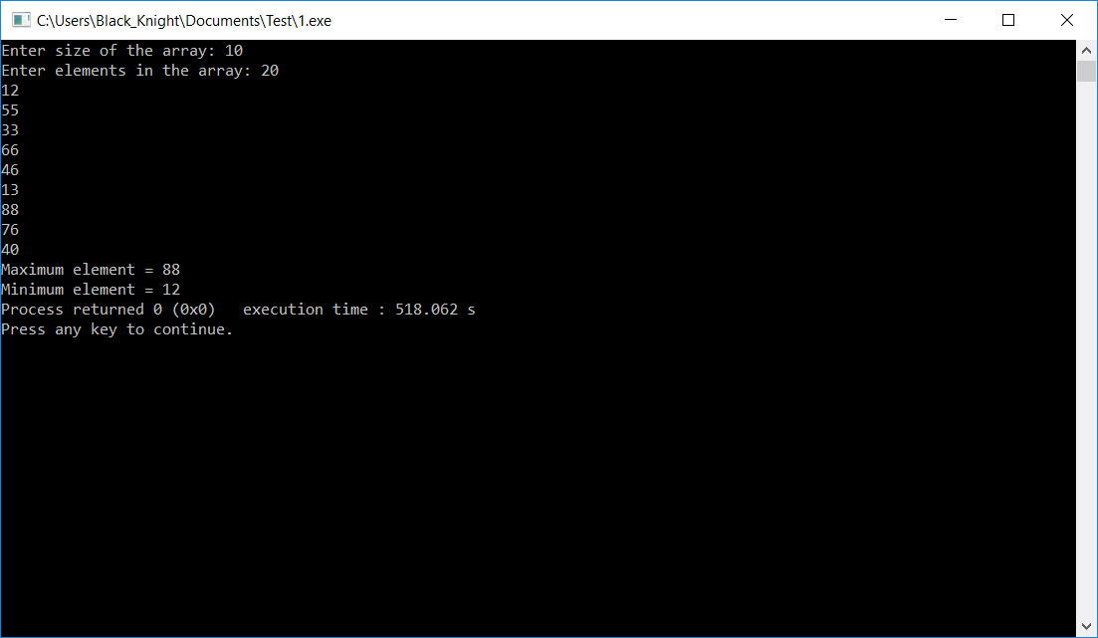

# Question 2

Create a character array and store your name in the array. Reverse the Word and display.

## ANSWER:

#include <stdio.h>

#include <stdlib.h>

void main(){

//Declaring Character array,variables

char name[50]="PUBUDU DANANJAYA";

char rev[50];

int p,q,r;

printf("My name is: %s",name);

for(p=0;name[p]!= '\0' ;p++){

r=p;

}

for(q=0;q<=p;q++){

rev[q]=name[r];

r--;

}

printf("\n\nReverse my name : %s",rev);

}

## ANSWER FIGURE:

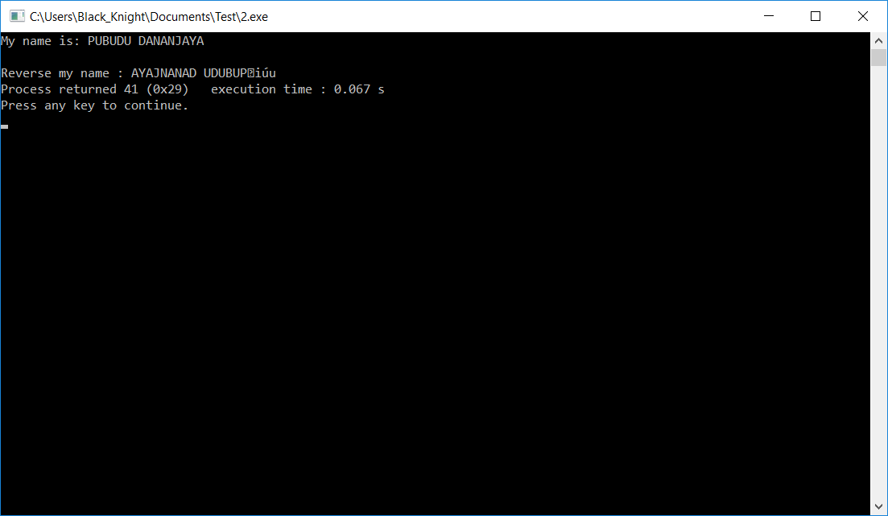

# Question 3

Write a function to input two values and display the power. Z=XY (X & Y are use inputs)

## ANSWER:

#include <stdio.h>

#include <math.h>

float power(float x,int y){

if(y != 0){

return(x*power(x,y-1));

}

else

return 1;

}

int main(){

float x,z;

int y;

printf("Enter base number: ");

scanf("%f",&x);

printf("\nEnter power number: ");

scanf("%d",&y);

z=power(x,y);

printf("%.2f^%d = %.2f\n\n",x,y,z);

return main();

}

## ANSWER FIGURE:

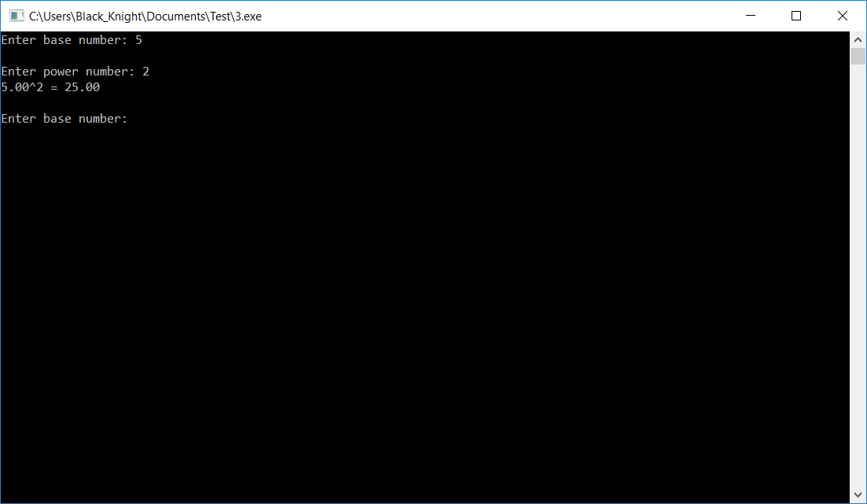

# Question 4

Write a menu driven program to add two values and display +,-,*,/ and % values. (Refer class notes and implement the solution using functions)

## ANSWER:

#include <stdio.h>

#include <stdlib.h>

#include <math.h>

float add(float num1,float num2){

float res=0;

res=num1+num2;

printf("Result is : %.2f",res);

}

int sub(float num1,float num2){

float res=0;

res=num1-num2;

printf("Result is : %.2f",res);

}

float mult(float num1,float num2){

float res=0;

res=num1*num2;

printf("Result is : %.2f",res);

}

float divi(float num1,float num2){

float res=0;

res=num1/num2;

printf("Result is : %.2f",res);

}

float remi(int num1,int num2){

int res=0;

res=num1%num2;

printf("Result is : %d",res);

}

int main(){

int ch;

float num1,num2;

printf("\nEnter number 1 :");

scanf("%f",&num1);

printf("Enter number 2 :");

scanf("%f",&num2);

printf("\n1.Addition\n2.Subtraction\n3.Multiplication\n4.Division\n5.Reminder\n6.Exit");

printf("\nEnter your choice :");

scanf("%d",&ch);

switch(ch){

case 1 :add(num1,num2);

break;

case 2 :sub(num1,num2);

break;

case 3 :mult(num1,num2);

break;

case 4 :divi(num1,num2);

break;

case 5 :remi(num1,num2);

break;

case 6 :exit(0);

break;

default :printf("Wrong choice! check and enter again");

}

return main();

}

## ANSWER FIGURE:

